Node JS -- Is a JavaScript Run Time

NPM – Node Package Manager

SPA – Single Page Application

TypeScript – Typed Superset of JavaScript

JavaScript will run in browser – Browser contains JS Engine which is responsible to run the JS code.

In case, if you like to JS code outside the browser – NodeJS is the option

NodeJS is based on the Google Chrome V8 Engine.

Node.js® is a JavaScript runtime built on [Chrome's V8 JavaScript engine](https://v8.dev/).

NodeJS is a Javascript Run time Environment to run any JS based applications

<https://nodejs.org/en/> -- official site

LTS – Long Term Support

When installing nodejs, npm also installed automatically

NPM – Node Package Manager (It is used to manage the dependencies of JS based applications)

In JAVA, we use maven for Dependency mgmt. (pom.xml)

In Javascript, we use npm for dependency mgmt. (package.json)

While installing any module using npm there are two installation types

1. Local installation - will install all the modules in the current folder (node_modules)
2. Global Installation (-g) - C:\Users\Siva\AppData\Roaming\npm

Angular JS is a Javascript based front end framework. (MVVM)

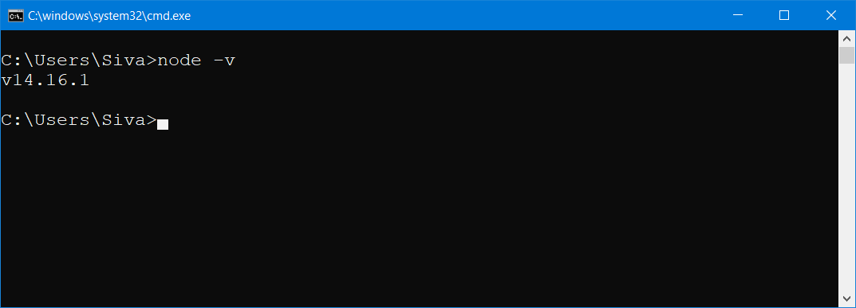

Npm -v

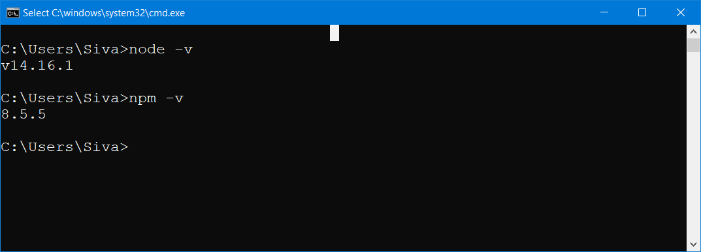

Package.json – This file contains all the dependencies in the form of JSON

JSON – JavaScript Object Notation

Creating package.json using npm init

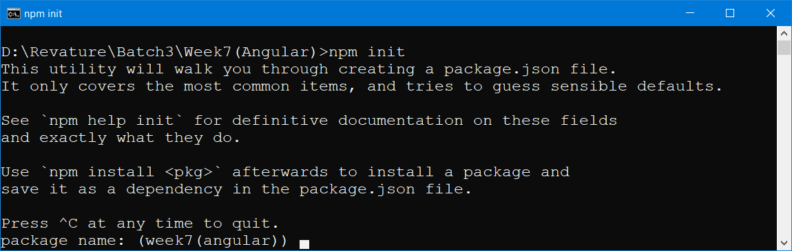

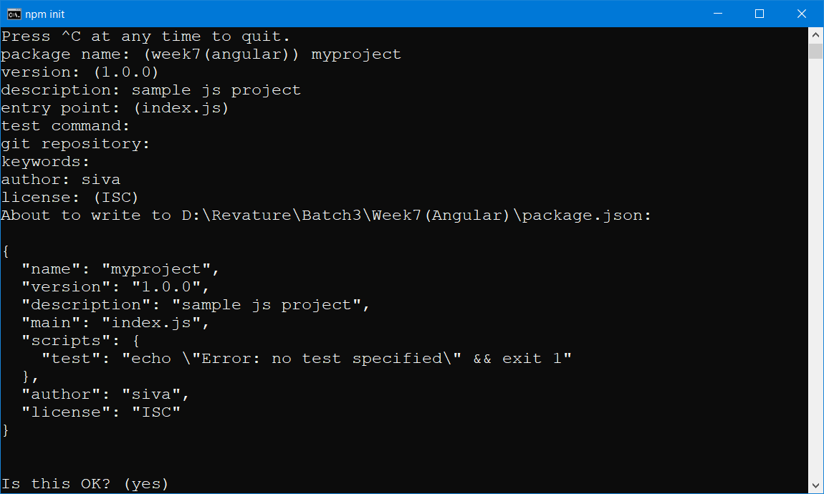

TypeScript – Typed Superset of JavaScript

JavaScript – Is a loosely/Dynamically typed lang

TypeScript – Is a Strongly typed lang.

TypeScript – Is a Open Source, Object Oriented and Developed by Microsoft

TypeScript Compiler = tsc

Typescript installation

Npm I typescript -g

Npm I -g typescript

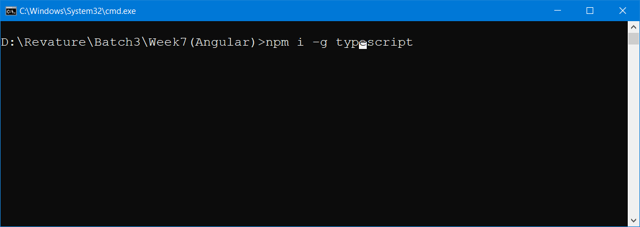

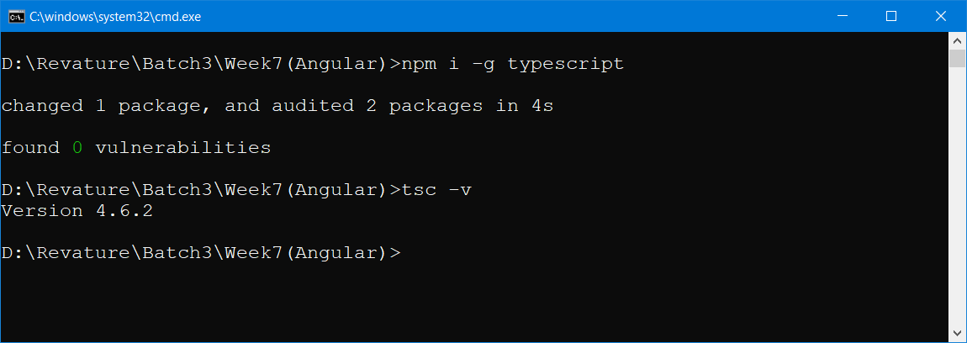

Transpilaton= Translation +Compilation (Converting one form of human readable format to another form of human readable format)

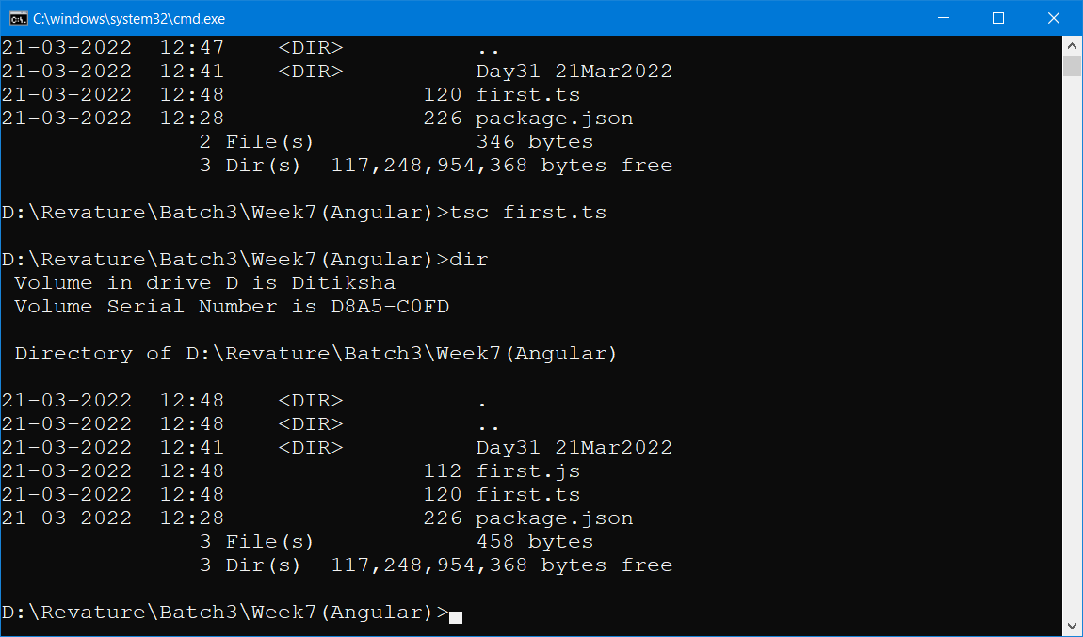

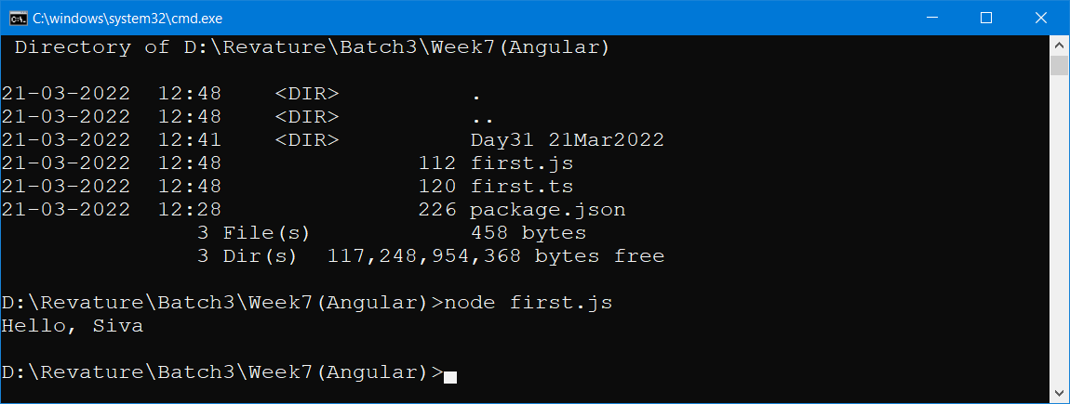

SPA – Single Page Application (Only one HTML which will have multiple components)

MPA – Multi Page Application (One HTML for one Page, index.html, aboutus.html, services.html,contactus.html)

Responsive Web Application = Look & Feel will remain same irrespective of the screen size (mobile, smart tv, tablet, laptop)

SPA = AJAX +HTML5 (No page Reload, will work in offline, traversing between components will be faster)